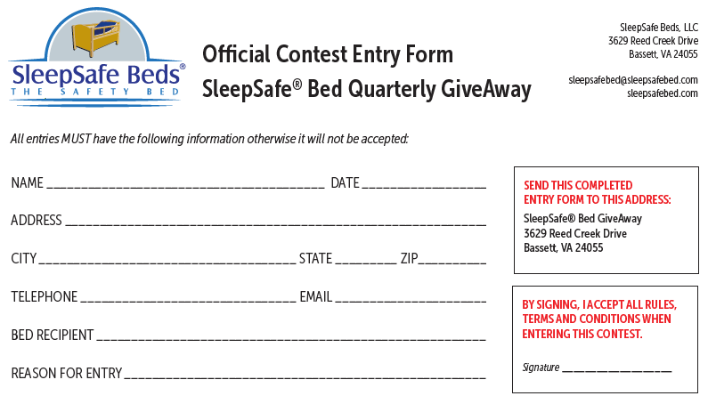
SleepSafe® Bed Giveaway Rules, Terms and Conditions

1. This SleepSafe® Bed Giveaway is intended to be used by those in need of complex care or rehab, particularly children.
2. We will give one SleepSafe® Bed per calendar quarter.
3. This giveaway bed is not redeemable for cash value or obtained for the purpose of resale.
4. Only one entry per household’s shipping address is allowed. Multiple entries to the SAME shipping address will be omitted.
5. This is a large bed coming by freight and will be sent to the winning address only, with NO EXCEPTIONS. Winning shipping address MUST be in the continental United States and Canada. Outside of the continental US or continental Canada, such as Alaska or Hawaii, the winner will be responsible for shipping charges. We will ship to the nearest point, and it will be the winner’s responsibility to make further shipping arrangements at their cost.
6. Contest is for private individuals only. No discrimination on age, race, religion, gender or disability. No dealer, agency, business entity, facility or school are eligible.
7. All entries must be received no later than four (4) business days prior to the last day of the month ending in that quarter:
1st Quarter ending March 2026 deadline for entering is March 26, 2026
2nd Quarter ending June 2026 Deadline for entering is June 24, 2026
3rd Quarter ending September 2026 Deadline for entering is September 24, 2026
4th Quarter ending December 2026 Deadline for entering is December 28, 2026
8. Drawing will be held and winner announced within one week following the last day of each quarter.
9. Winner will be announced in the following ways:
1st: Personal phone call to phone number provided with entry by 5:00 pm on the day of drawing.
2nd: Posted on our website within 2 business days of drawing.
3rd: A letter will be sent via US Postal service to the shipping address provided with entry.
4th: Winner’s name will be available to anyone who calls, writes, faxes or emails SleepSafe® Beds after 2 business days following drawing.
10. Winner must choose bed within 10 business days of winning notification by calling SleepSafe® Beds at 866-852-2337. Bed will ship 2-4 weeks after order is complete. It is the winner’s responsibility to place order. Winner will forfeit bed if they do not contact SleepSafe® Beds within 10 days of notification.
11. Winner will be responsible to plan to accept delivery of the bed via the freight company. SleepSafe® Beds will be responsible for all shipping
charges associated with sending the bed from our facility in Bassett, VA to the winning address. The bed will arrive by TForce Freight or Estes Freight. We will make arrangements for the bed to be delivered to the residence, unloaded from the truck and brought to the first inside location. Winner should be aware that this is sometimes only the garage. The shipping company WILL NOT unpack the bed nor will they bring it in the room of choice or assemble the bed. It is the sole responsibility of the winner to make arrangements for set up, assembly and removal of any pallets or boxes. The freight company will call the phone number provided on the winning entry prior to schedule delivery. Once the bed is received at the local distribution center of the winning entry, the freight company will call to schedule a time that is convenient for the winner to accept delivery. If the freight company schedules a time for delivery and for any reason is unable to deliver the bed because of changes made by the winner, the winner shall be responsible for any re-delivery fees that may be assessed by UPS Freight.
12. Maximum RETAIL value of any bed will not exceed $12,500.00. The winner may choose any bed size, foundation, wood color and optional accessories as long as their total choices do not exceed maximum value. SleepSafe® Beds will work with the winner to receive a bed that best meets the dollar limit.
13. Winning entry will be randomly drawn by hand from the entries sent to us during the appropriate quarter.
14. SleepSafe Beds, LLC will not be responsible for entries not received because of mail delivery failure in any way.
15: Our current Manufacturer’s Warranty will be applicable to all prizes given.
16: Acceptance of a bed: By accepting a bed, winner agrees to have name released on our web site, sleepsafebed.com, or to anyone who contacts us to verify the winner.

